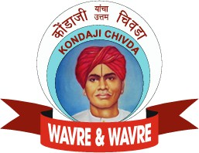



K O N D A J I C H I V D A

N A S H I K ’ S I C O N I C S N A C K

A T A S T E T H A T D E F I N E S T R A D I T I O N

# T A B L E O F C O N T E N T S

01 Introduction

05 Manufacturing & Quality Control

1. History & Origin 06 Competitors & Unique Selling Points
2. Ingredients
3. Varieties

07 Trademark certified

08 Contact Us

# I N T R O D U C T I O N

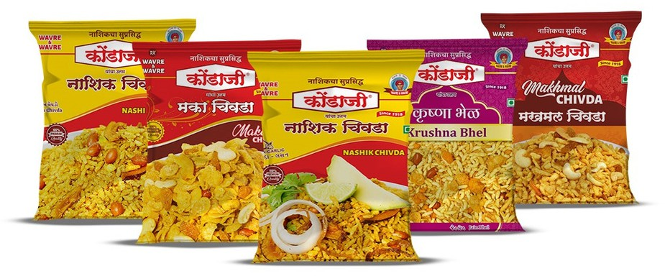Kondaji Chivada Nashik Special offers a delectable blend of crunchy chivda infused with the bold flavors of onion and garlic. This special chivda, renowned for its unique taste, combines crispy rice flakes with aromatic spices to deliver a savory, irresistible snack. Perfect for enjoying with tea or as a flavorful addition to any meal.oIt's made of puffed rice, edible oil and a choice of spices which cannot be imitated and has been a recipe for more than a century.

A widely popular mix, famous, since 1918, for its tongue teasing taste & Authentic flavour. No artificial colour, No Flavour, No preservative.oRoasted poha, Refined edible vegetable oil, Groundnuts, Roasted Gram, Sugar, Spices, Coconut, Cocum, fried onion, garlic ,Salt.

.

# H I S T O R Y & O R I G I N

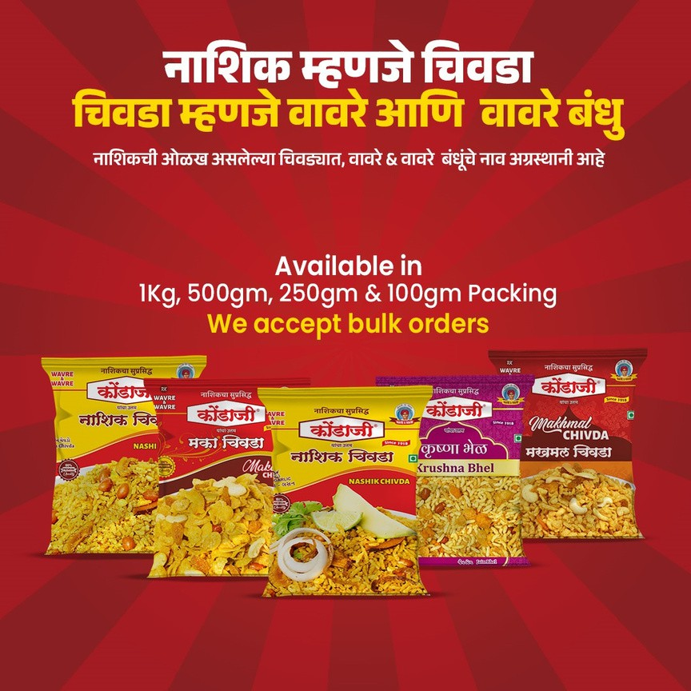Established in the year 1918, by Late. Kondaji Gunaji Wavare, in Nashik(Gangaghat)

# I N G R E D I E N T S

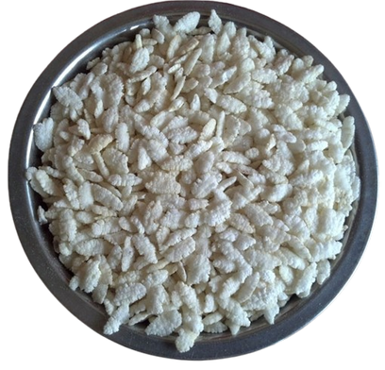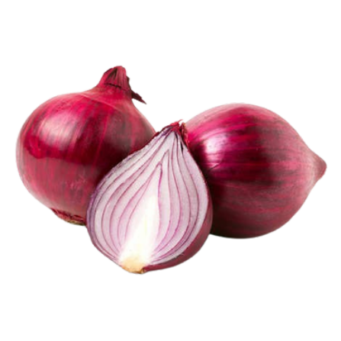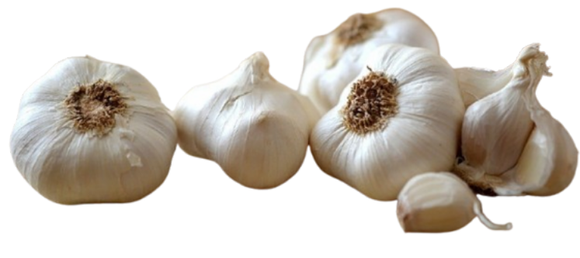

Crispy rice flakes Onion Garlic

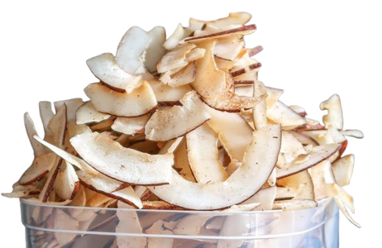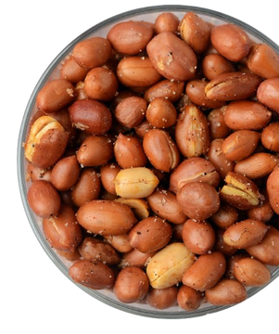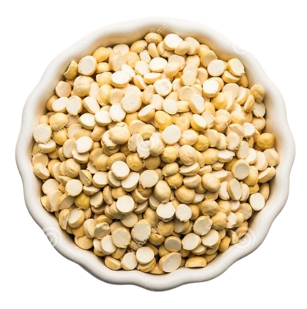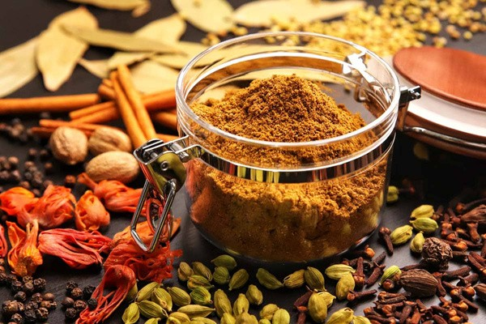

Coconut Flakes Fry Peanuts Dalya Spices

# V A R I E T I E S

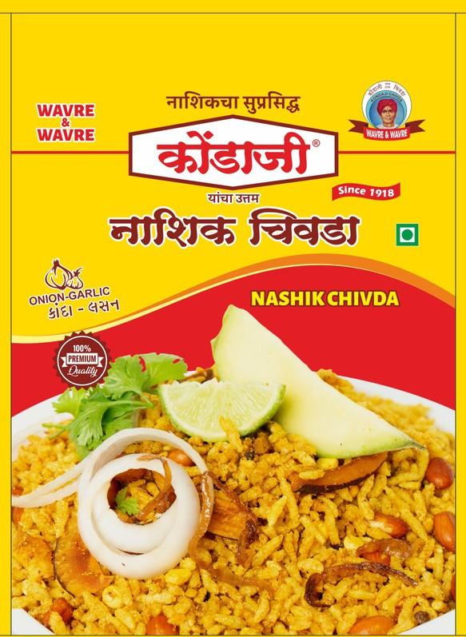

**01** NASHIK CHIVDA

This Is Our Signature Product For The Last 100 Years. It's Made Of Puffed Rice, Edible Oil And Choicest Of Spices Which Cannot Be Imitated And Is A Secret Recipe For More Than A Century. Nashik City Is Known For This Variety Of Chivda So Much So That Nashik City And KondajiChivda Have Become Synonymous.

This Is The Most Sought After Chivda In India As Well

As Abroad

Krushna Bhel

**02** Krushna Bhel is one of the most famous and beloved item. Known for its perfect balance of tangy, spicy, and crunchy flavors, this bhel has gained a cult following among locals and tourists.

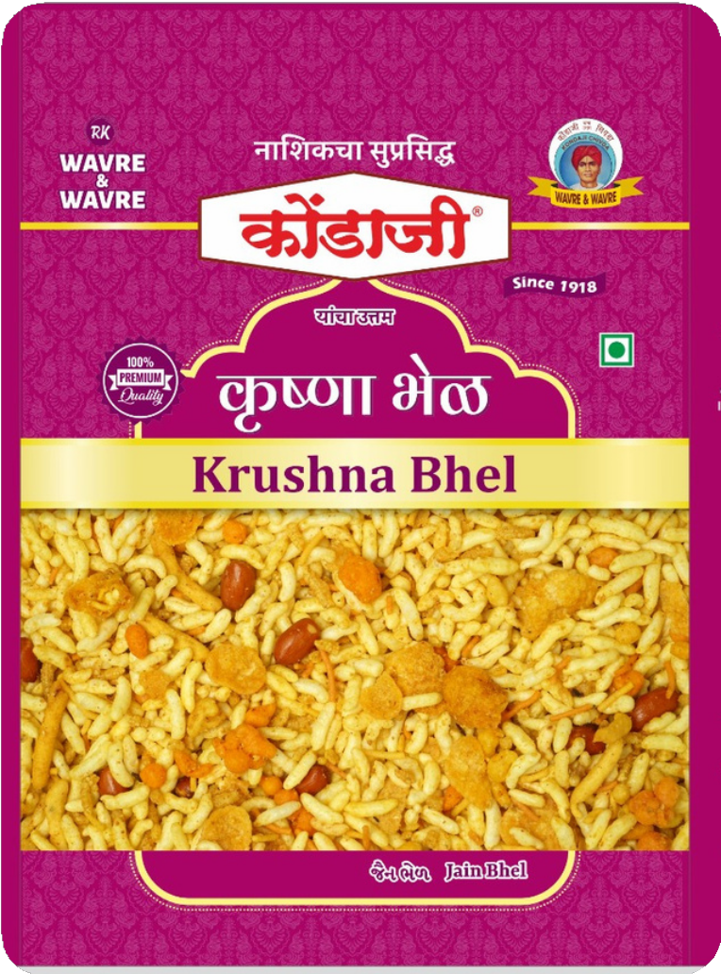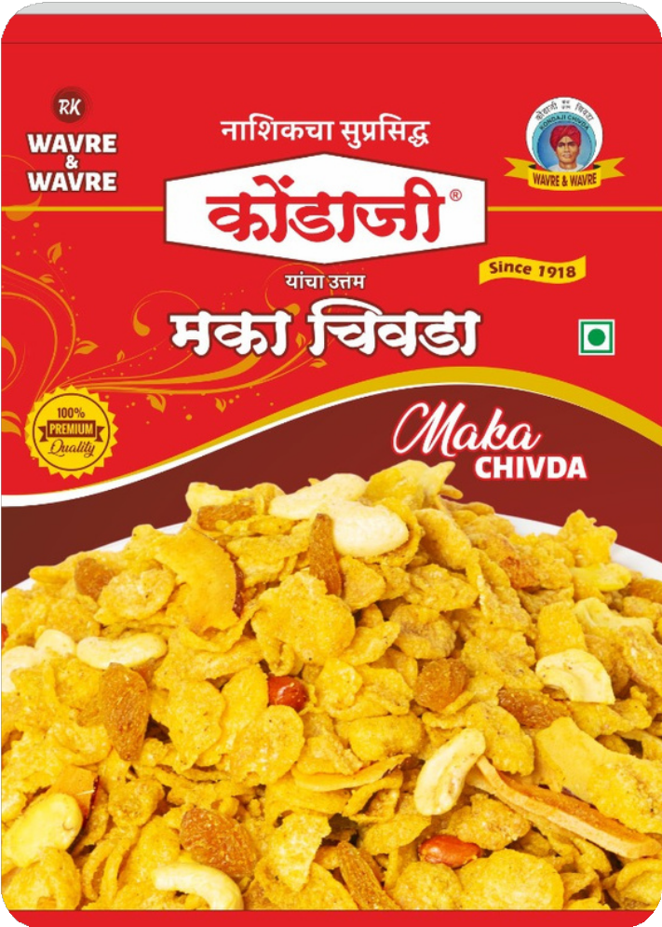

**04**

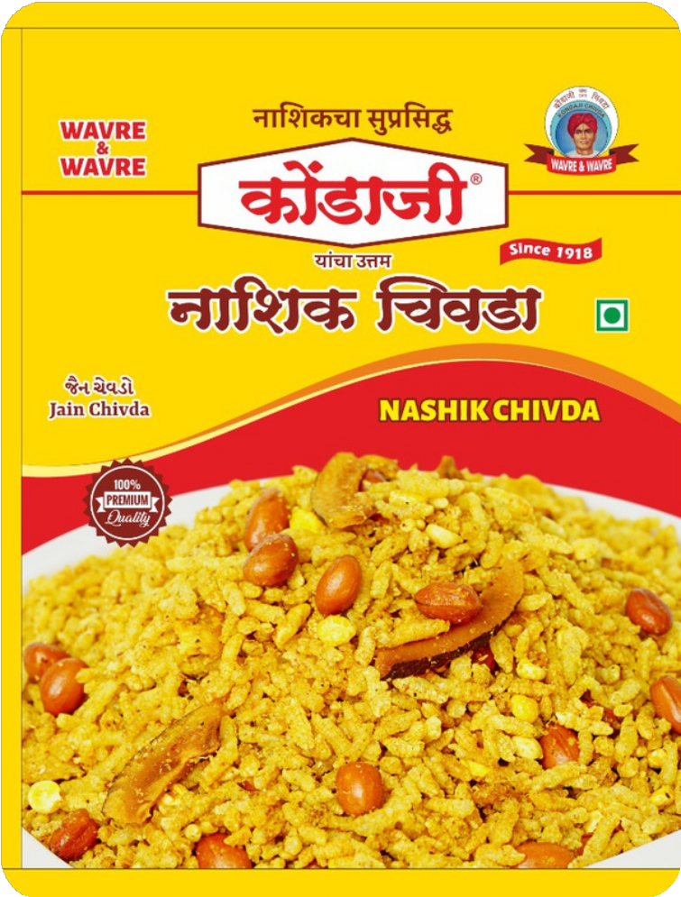

**05**

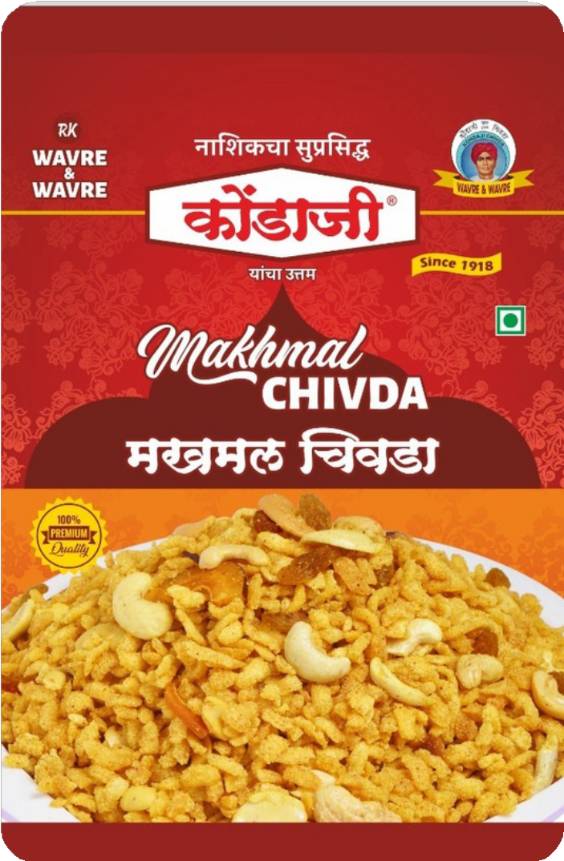**03** MAKHMAL CHIVDA

This is a premium variety of chivda made from a specific

type of rice produced specially for this chivda. Dry fruits like cashews and raisins, peanuts etc are added to it. It has got a sweet, spicy and tangy taste to it. Small children will also appreciate its taste

# M A N U F A C T U R I N G & Q U A L I T Y C O N T R O L

## Manufacturing Process

 Ingredient Selection – High-quality poha, nuts, spices, and oil.

 Automated & Hygienic Processing – Modern equipment for uniform roasting & mixing.

 Traditional Recipe – Maintaining authentic taste with standardized methods.

 Packaging – Air-tight, moisture-proof packs for freshness and longer shelf life.

## Quality

 Raw Material Testing – Ensuring premium-grade ingredients.

 Hygiene & Safety Standards – Regular sanitization of machinery & workspaces.

 Batch Testing – Checking taste, texture, and quality consistency.

 Certifications – FSSAI compliance, food safety audits & quality assurance.

# C O M P E T I T O R S & U N I Q U E S E L L I N G P O I N T S

### Competitors

 Haldiram’s

 Balaji Wafers

 Laxmi Chivda .

 Madhavji Ka Badhiya Chivda

 KARHAD BANDHU BHEL BHATTA

 Sanap Bandhu - Chivda & Bhel Bhatta

### Unique Selling Points

 Authentic Nashik Flavor – Traditional recipe passed down through generations.

 Premium Quality Ingredients – Handpicked poha, spices & nuts for superior taste.

 Heritage & Brand Trust – Well-known, trusted local brand with a loyal customer base**.**

 Eco-Friendly & Smart Packaging – Sealed packs for convenience and freshness.

 Custom Variants & Festive Packs – Special editions for festivals and gifting.

# C E R T I F I C A T I O N S

Trade Marks Registry FSSAI Certificate QMS Certificate

# C O N T A C T U S

**E-mail** [wavreandwavre@rediffmail.com](mailto:wavreandwavre@rediffmail.com)

**Website** [www.kondajchivdanashik.in](http://www.kondajchivdanashik.in/)

**Phone** 9923334252/9823178657

**Address** 1140, Bhadrakali Market, Nashik-01 (MS)

THANK YOU